Project Design Phase
Solution Architecture

Date | 15 February 2025
Team ID
Project Name | Online Complaint Registration
Maximum Marks | 4 Marks

Solution Architecture:
For the Online Complaint Registration and Management System, the solution architecture aims to:
- Select suitable technologies to provide secure complaint registration, tracking, assignment, and management.
- Define the system structure using React.js, Node.js, Express.js, MongoDB, and REST APIs.
- Identify system features and requirements for Users, Agents, and Administrators.
- Provide a clear development structure for authentication, complaint management, agent assignment, status updates, and communication.
- Ensure security and scalability through JWT authentication, role-based access control, and a decoupled MERN architecture.

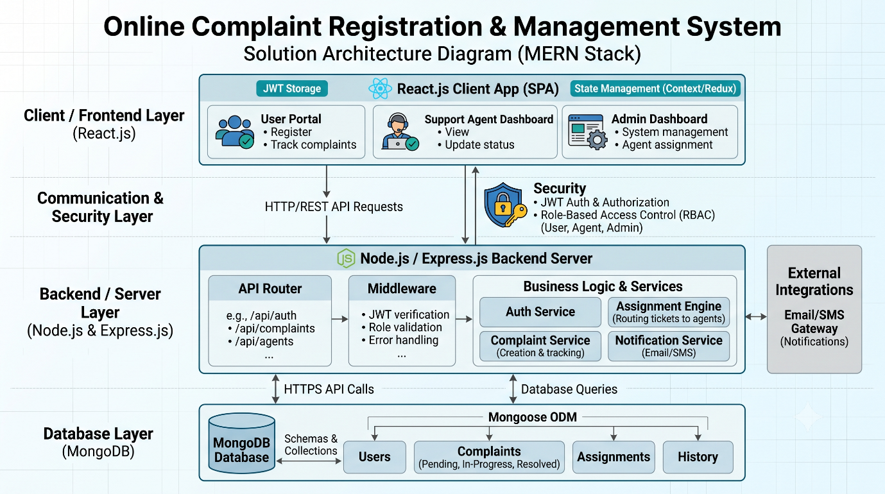
Example - Solution Architecture Diagram:

Figure 1: Architecture and data flow of Online Complaint Registration and Management System

